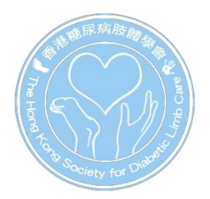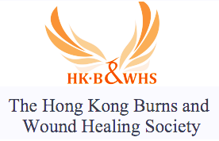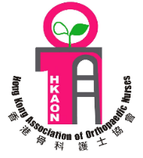
2019 Symposium on Wound Healing - from Traditional to New Advances
6pm-8pm, 6th September 2019
9am-5pm, 7th September 2019
HKEC Training Centre, Pamela Youde Nethersole Eastern Hospital,
3 Lok Man Road, Chai Wan, Hong Kong
Registration Form
Title | Professor / Dr. / Mr. / Ms. | Profession
Family Name |  | Given Name
Department |  | Institution
Country |  | Contact Number
Correspondence Address
E-mail

Category | Early Bird  (until 31th July 2019) | After 31th July 2019
Doctor | 600 HKD | 750 HKD
Doctor (HKSDLC Member) | 500 HKD | 650 HKD
Nurses and Allied Health | 400 HKD | 550 HKD
Nurses and Allied Health (HKSDLC Member) | 300 HKD | 450 HKD
Student | 200 HKD | 350 HKD
Overseas Registration | 100 USD | 120 USD

Please send the registration form together with the cheque payable to " The Hong Kong Society for Diabetic Limb Care Limited " to LG 102, Block K, Queen Mary Hospital, 102 Pokfulam Road, Pokfulam, Hong Kong | 

Fax: 2255 3800 Enquiry: info@diabeticlimb.hk Website: https://www.diabeticlimb.hk

